

Dr. Jerry, Pennington inc.
2020-05-28
Dr. Pennington
PSC 7398, Box 7457, APO AA 39697
Phone: 7108513558
Fax: 727706983

Re: Anna, Kelly
PHN: 6925661712
Birthdate: 12-Aug-1975
Address: 87033 Samantha Pines Apt. 386, Port Joshua, MT 24924
Patient number: 6742412360

To Whom It May Concern:

This is a medical letter to state the above patient is pregnant with expected delivery date of 09-Aug-2025. Hoping this information is satisfactory for your requirements.

Thank you.

Sincerely,
Dr. Jerry, Pennington
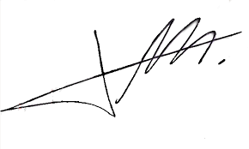
FRCS© NCMP
Clinical Assistant Professor, UBC
Department of Obstetrics and Gynecology SMH

